Novartis Institute
100 Technology Square, Cambridge, MA 02142

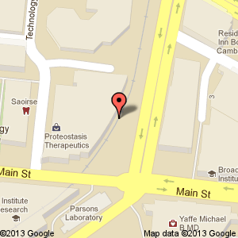
Area map

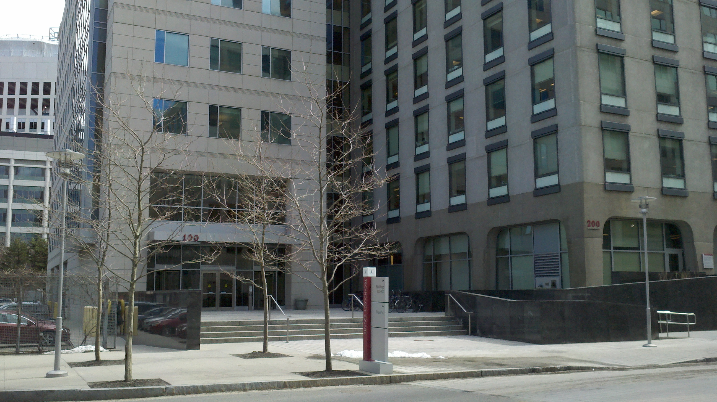
Street view: The main entrance is on left when you are facing the building

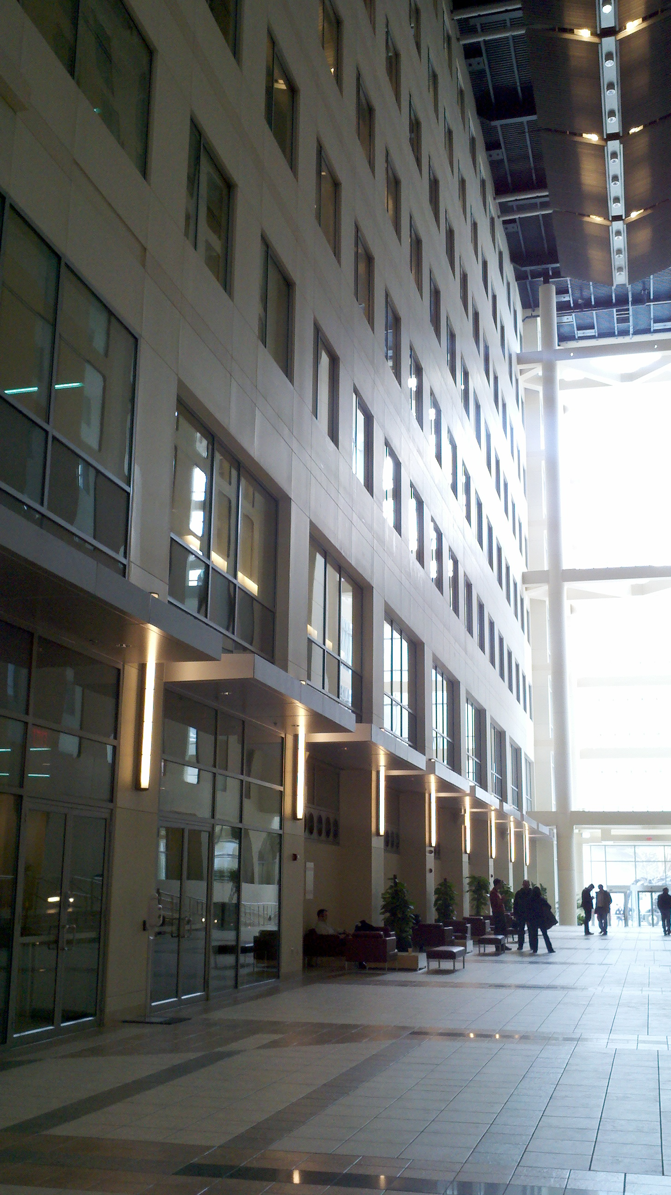
Transition entrance

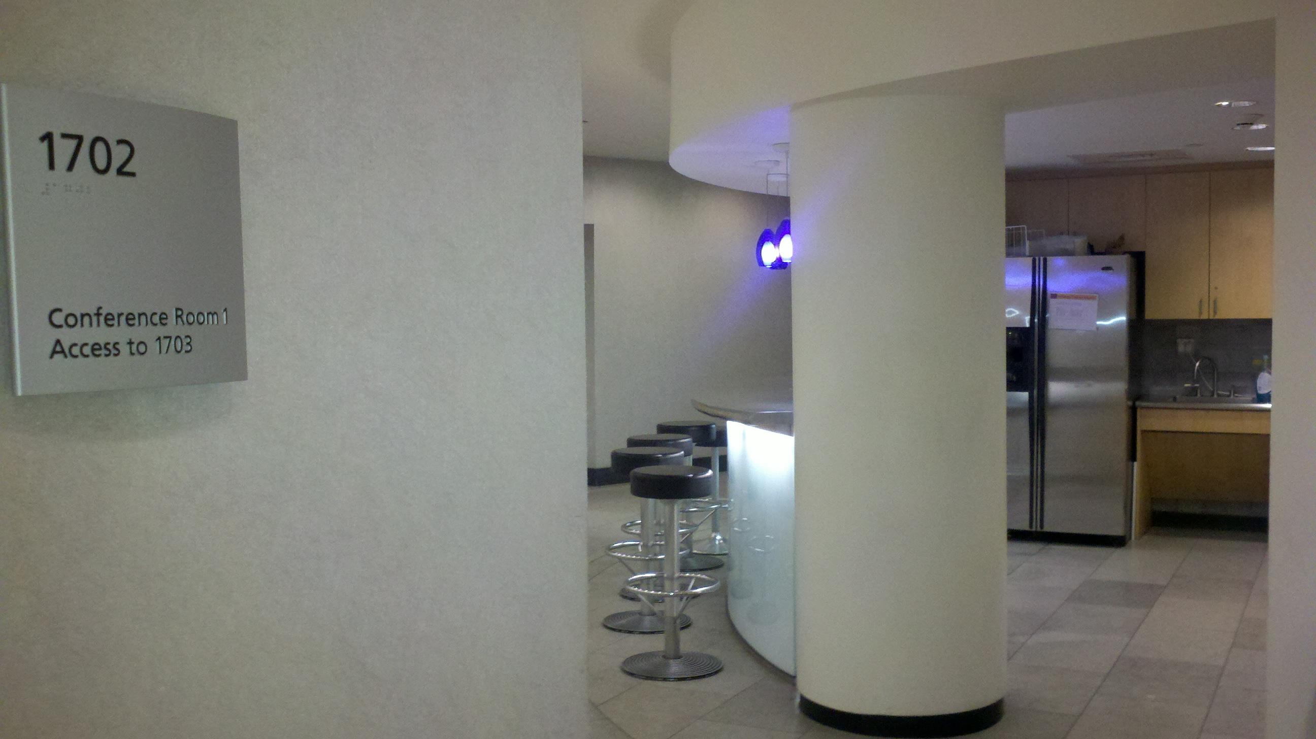
Outside room 1702

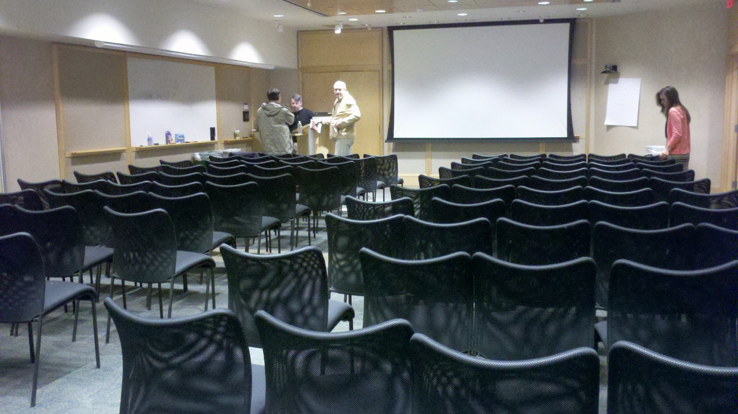
Rooms 1701/1702

Parking Options:
- Technology Square Garage
  - 2-3 hours = $14, 3-8 hours = $18, 8-24 hours = $23
- Metered Street Parking
  - $1 per hour (quarters only) and free after 6 p.m.
- Marriott Hotel Garage (.3 miles away)
  - $25 for the day or $35 for valet
- New England Research and Development Center Garage (.6 miles away)
  - $10 for the evening with arrival after 4pm

